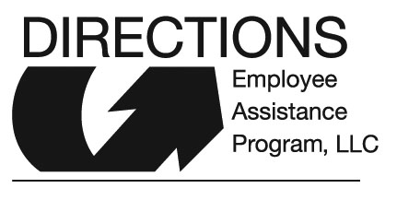

Directions EAP
Client Satisfaction Survey

This survey is optional and completely confidential. Since you have recently used your EAP, we are eager to learn from your experience in an effort to improve the service that we offer.

Your employer is:___________________________________________________________

How did you learn about Directions EAP?
_____Company Brochure _____Co-Worker
_____Manager or Supervisor _____Human Resources
_____Family Member _____Other

How satisfied were you with your recent Directions EAP experience?
_____Extremely Satisfied
_____Satisfied
_____Not Satisfied

How likely would you recommend Directions EAP?
_____Extremely Likely
_____Likely
_____Not Likely

Were you able to get an appointment scheduled within a reasonable amount of time?
_____Yes
_____No

Was the office in which you received counseling convenient & comfortable?
_____Yes
_____No

How effective was the counselor in helping you with your problem or concern?
_____Extremely helpful
_____Helpful
_____Not helpful

How comfortable were you sharing confidential information with your counselor?
_____Extremely
_____Somewhat
_____Neither

Counselor’s Name:___________________________________________________________
Comments:_________________________________________________________________
___________________________________________________________________________

Please complete after your last EAP session and mail or complete on line at www.directionseap.com by clicking on the Client Satisfaction Survey in the Employee Section.

Directions EAP, LLC
3930 South St, Suite 101
Lincoln, NE 68506

